Understanding Payroll
AEC
For All
Awareness · Exploration · Connections

21st Century Career
Activity 2- October

Intern/Apprentice’s name:

Directions: If you have more than one release period, you may complete the Payroll Activities as a series, completing one activity per month. At least one monthly work-ethic topic activity/activities must still be completed for you to meet the required monthly activities portion of this program. (Ex- If you have two (2) release periods, you could complete one work-ethic activity and one payroll activity to meet the monthly activity requirements.)

Where appropriate, please write thoughts/answers in COMPLETE sentences. Math calculations must be shown (keyed or written) to receive credit. Remember, you are receiving a grade for this assignment.

2. Payroll Taxes: Dependents/Allowances- What you have to say about the money that comes from your paycheck and goes to taxes!

Let’s start by looking at Federal and State Income Taxes…..

Our government collects income tax based on the amount of money you earn every calendar year, January – December. Think of the process like this:

- You worked during 2014 and by the end of the year, you had earned $22,100. | - Based on your $22,100 income, the federal government determined that you owe around $1,923 in federal income taxes for 2014.
- Based on your $22,100 income, the state government determined that you owe $1,326 in state income taxes for 2014. | - Would you prefer to pay these amounts in one lump sum or pay a small amount WITHHELD from each paycheck?  The withholding process helps you pay a little from each paycheck so that you won’t owe the entire amount at once when you file your tax return every year by April 15th!

Good news- YOU determine how much is withheld from each paycheck! It all depends on how much of your pay you can afford to pay in for taxes and how much you need to keep for living expenses.
For example:
These two men have the same job, work the same number of hours, and earn the same pay. However, the amount they get to bring home is very different. (This could be women, too!)

Married couple with four children Single person, unmarried, no children

Consider this: Which man will require more money in his pocket to spend on groceries, medical needs, clothing, daycare, insurance, etc. With that in mind, which one needs to bring home as much of his earnings as possible to meet the needs of his household?
The government requires less tax from the married father’s pay because he has four children that DEPEND on him to meet their needs. The married man’s children are called his DEPENDENTS/ALLOWANCES. Spouses are not considered a dependent in ordinary circumstances. Because the single person has no dependents, the government requires more tax from his pay; thus he brings home less money than the married man with the family.

DO THE MATH: You are single and get paid $850 every two weeks or ‘biweekly’.
How much should your employer withhold from your check for federal taxes? Since you are single and have no children, you only have one allowance (1), yourself.
How much will come out of your paycheck for federal taxes?
Look at the partial federal withholding table below and notice the circled items:

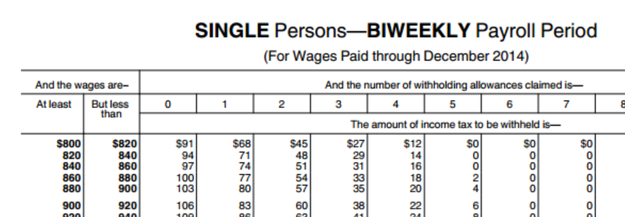

If you said, $74, you were correct!

Go to next page

If you were married and earning $1,775 biweekly and had 4 allowances,
how much would come out of your paycheck for federal taxes?
Look at the partial federal withholding table below and notice the circled items:

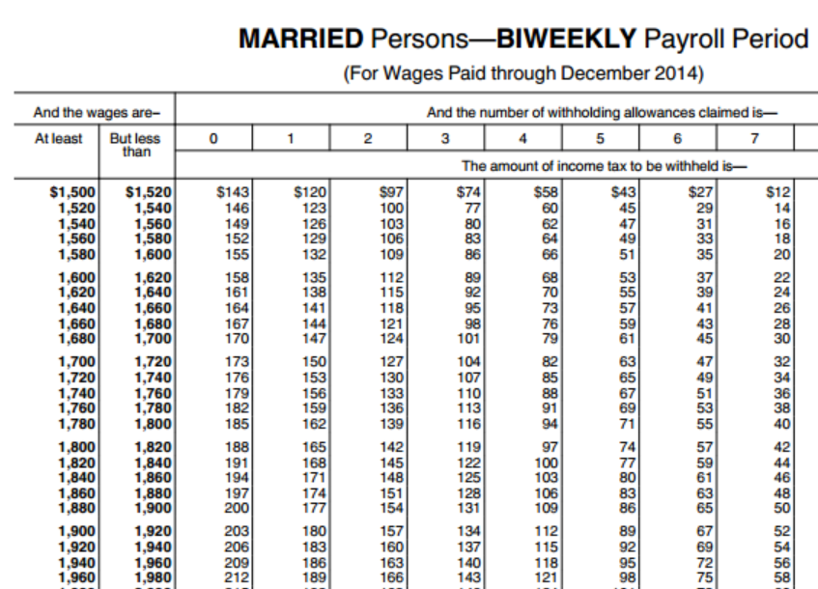

If you said, $91, you were correct!

So, how does your employer know how much to withhold from your pay?
When you go to work as a new employee for an organization, they are legally required to keep part of your pay and send it to the government for tax purposes. The only way an employer can withhold the correct amount is for you to provide them with correct information. You provide this information by filling out withholding forms. You will be required to complete withholding forms each time you start a new job.

To withhold the correct amount for your To withhold the correct amount for your
Georgia state taxes, you will complete a G-4 federal (USA) taxes, you will complete a W-4
Form W-4
Form G-4

Payroll Activity 2- October: Instructions:

Complete forms G-4 and W-4 as if you were a new employee. You will access the forms through the links provided. READ the form instructions and fill out the forms the best that you can. Use your actual name and address but use an artificial social security number.

Form G-4: Open the link, follow the instructions and complete the Form G-4. Save the form as a PDF with FirstLastNameG4 and submit through Dropbox. You will not be able to sign the form but you can date it.
http://dor.georgia.gov/sites/dor.georgia.gov/files/related_files/document/TSD_Employees_Withholding_Allowance_Certificate_G4.pdf

Form W-4: Open the link, follow the form instructions and complete PAGE 1 ONLY for Form W-4. Save the form as a PDF with FirstLastNameW4 and submit through Dropbox. You will not be able to sign the form but you can date it. http://www.irs.gov/pub/irs-pdf/fw4.pdf

