Industry Case Study

Employability Skills Area: Work Habits - Time Management - Appearance Assignment Name: When At Work

Read the situation below related to the Employability Skills Area. Work Habits.

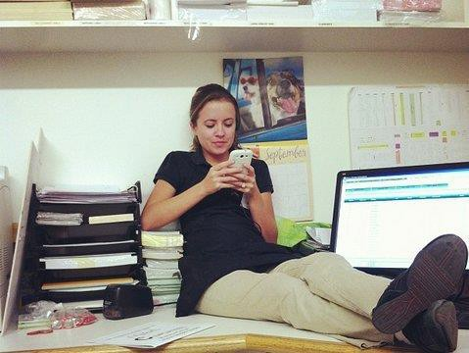
Situation:
You’ve been hired and given the responsibility of talking with customers regarding past due payments. You’ve been given a lot of authority and responsibility with this position. After proving your ability to collect and remain respectful with sometimes belligerent customers, it is discovered you’ve made multiple personal phone calls while on company time. In fact, there is documentation that every day at the same time, you’ve talked for 30 minutes to friends/family. Though you are not face- to-face with the public, your dress now becomes an issue. The amount of good you’ve done seems to no longer matter and every move or action you make is under a microscope.
Directions: Type a 150-word (minimum) response below to this situation and make sure you address the three questions in your response.
- Even if not seen, is it worth it to “disrespect” the company by being paid while you are making personal phone calls?
- If you were the employer, how would you handle this situation?
- How should the employee handle their personal business during a workday?

Response:

