Industry Case Study

Employability Skills Area: Organization and Responsibility Assignment Name: Activity 1 Quarterly Review
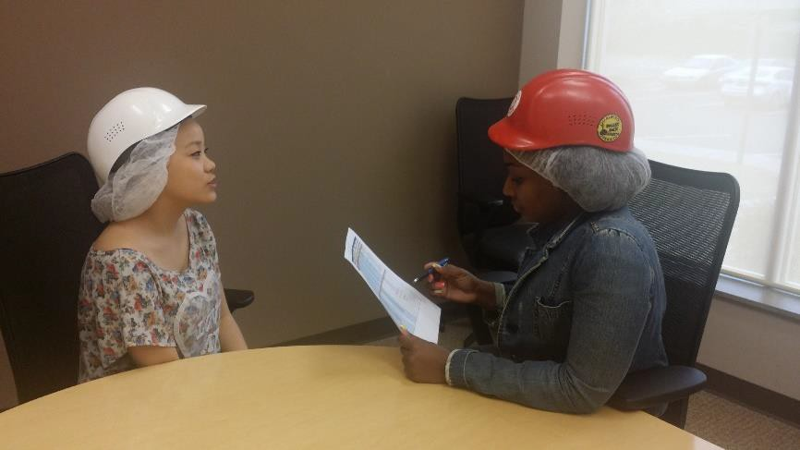
Read the situation below related to the Employability Skills Area. Organization and Responsibility.
Situation:
You have worked for a manufacturing company for about three months, and it is time for your 90-day review. At this meeting, your supervisor will be discussing your performance (which is very good) with you. The supervisor would also like to hear your thoughts about working for the company.
Directions: Type a 150-word (minimum) response below to this situation and make sure you address the three questions in your response.
- What should you tell the supervisor?
- What should you ask the supervisor?
- If you were being reviewed on your current job/internship, what are three things you can improve on?

Response:

