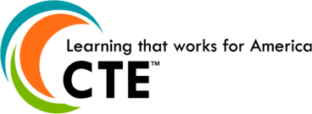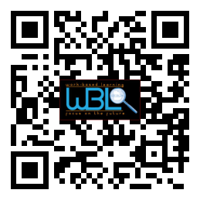****0

*A huge thanks to Zaxby’s for sponsoring lunch for our board members and guests! We appreciate your generous support.*

### May 4th, 2015

### 11:30 a.m. - 12:30 p.m.

### Hall County Schools

*711 Green Street*

*Gainesville, GA 30501*

* **Welcome & Approval of Minutes**

Mike Holman, WBL Chair, Baldor

* **WBL Success Stories**

Julie Brumble, Human Resources, Chick-Fil-A

Emmy Dale, Marketing, Chick-Fil-A

Laquita Dooley, Educational Services, NEGMC

Linda Hammontree, Human Resources, Kipper Tools

Mike Holman, Plant Manager, Baldor

* **WBL Orientation and FAQ**

Felecia Doyle, WBL Coordinator, Flowery Branch

* **2014-2015 WBL Highlights**

Kirsten Fowler, WBL Co-Chair

* **Fall 2015 Action Items**

Mike Holman, Chair

* **Questions/Closing Remarks**

**Advisory Committee Officers**

Mike Holman, Chair

Kirsten Fowler, Co-Chair

Holli Howard, Committee Coordination

Cree Aiken, Secretary

**Hall County WBL Coordinators**

Holli Howard, Chestatee High

Staci Crain, East Hall High

Christy Carter, Flowery Branch High

Felecia Doyle, Flowery Branch High

Cree Aiken, Johnson High

Karen Filchak, North Hall High

Deana Harper, North Hall High

Suzanne Haynes, North Hall High

Shenley Rountree, West Hall High

**Hall County CTAE Director**

Rhonda Samples

## AGENDA

# WBL/YAP Advisory Committee