Industry Case Study

Employability Skills Area: Responsibility Assignment Name: Take Ownership For Actions

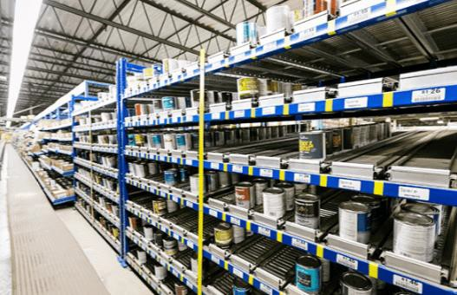
Situation:
A supervisor walking through the warehouse noticed damage to a rack used to store paint products. Based on earlier observations, it was clear the damage was recent. All employees were called together for a meeting at the site of the damage and asked if anyone had information. No one came forward. Later an employee stated he saw the incident and knew who did it. Ultimately, the employee who did it admitted to the damage after repeated opportunities to take responsibility and only after being confronted with evidence that the other employee witnessed the damage. The employee who caused the damage is a veteran employee with good performance. The company rules are to report all incidents or equipment damage immediately. Frequently, employees damage equipment and it is repaired when reported and there is not disciplinary action. This employee was given a 3-day suspension. Company rules allowed for termination due to failure to report incidents.

Directions: Type a 150-word (minimum) response below to this situation and make sure you answer the three questions in your response.
- What should have the employee done immediately following the accident?
- Why do these incidents need to be reported?
- What would you do as the employer, as the supervisor and as the coworker?

