00



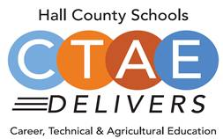

* **Welcome, Approval of Minutes**
  + Greg Vitek, Chair, Work Force Strategies Group
  + Website: [www.hallcowbl.org](http://www.hallcowbl.org)
  + Password: wblworks
* **WBL Student Spotlight**
  + Adrian Lopez, IMS Gear, JHS
* **Update Advisory Members Contact, QR Code**
  + Carin Booth, CBHS
* **CTAE District & COVID-19 Updates**
  + Rhonda Samples, CTAE Executive Director
* **Comprehensive Local Needs Assessment Follow-Up** 
  + Heather Barrett, CTAE Assistant Director
* **Career Pathway Industry Poster Work Session**
  + Greg Vitek, Chair, Work Force Strategies Group
* **New Business**
  + Next Meeting:
    - January 19, 2021

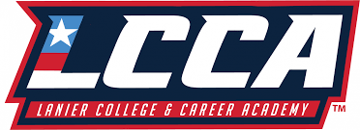

**Thank you to our lunch sponsor!**

**Advisory Council**

Greg Vitek, Chair  
 Work Force Strategies Group

Tabitha Weaver, Secretary  
 Energetix LLC

**Hall County Career Specialists**

Carin Booth, Cherokee Bluff

Holli Howard, Chestatee High

Kami Kovach, East Hall High

Christy Carter, Flowery Branch High

Cree Aiken, Johnson High

Kim Guy, Lanier College and Career

Kristi Sims, North Hall High

KayLynn Samples, North Hall High

Suzanne Haynes, West Hall High

**Hall County CTAE Staff**

Rhonda Samples  
 CTAE Executive Director

Heather Barrett  
 CTAE Assistant Director

Deana Harper  
 WBL/YAP Coordinator

[www.hallcowbl.org](http://www.hallcowbl.org) PW: wblworks

## AGENDA

### September 29, 2021

### 11:30 a.m. - 12:30 p.m.

### Lanier College and Career Academy

2719 Tumbling Creek Rd.  
Gainesville, GA 30504

# CTAE / Work-Based Learning

# Advisory Committee