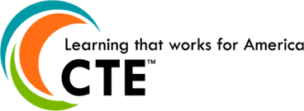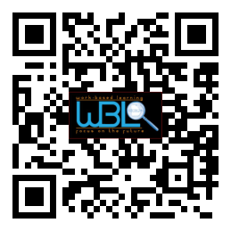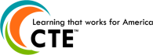0

**Hall County WBL Coordinators**

Holli Howard, Chestatee High

Staci Crain, East Hall High

Christy Carter, Flowery Branch High

Felecia Doyle, Flowery Branch High

Cree Aiken, Johnson High

Karen Filchak, North Hall High

Deana Harper, North Hall High

Suzanne Haynes, North Hall High

Shenley Rountree, West Hall High

* **Welcome & Introductions**

Rhonda Samples, CTAE Supervisor, Hall County Schools

* **Purpose/Mission of Advisory Committee**

Holli Howard, WBL Coordinator, Chestatee

* **WBL Success Stories**

Gracie Braselton, Flowery Branch High

Allie Reed, Chestatee High

* **Involvement Opportunities**

Deana Harper, WBL Coordinator, North Hall

* What WBL can do for you
* How you can help WBL
* Current WBL needs
* Committee member recommendations
* **Future Meeting Dates**
* **Meeting Ideas?** 
  + Georgia BEST Soft Skills Program
  + Elementary Career Lessons

Please email suggestions to [holli.howard@hallco.org](mailto:holli.howard@hallco.org)

* **Questions/Closing Remarks**

## AGENDA

# WBL/YAP Advisory Committee

### October 28, 2014

### 11:30 a.m. - 12:30 p.m.

### Hall County Schools

*711 Green Street*

*Gainesville, GA 30501*