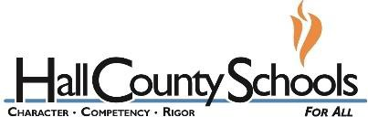
Industry Case Study

Employability Skills Area: Respect Assignment Name: Merit

Situation:
Recently, due to a healthy financial year, merit pay increases were rewarded. Each person, when receiving their pay increase, was asked not to discuss the amount awarded. It, of course, became the topic of conversation for days among the staff. Because it was shared, animosity was spread throughout the team.

Directions: Type a 150- word (minimum) response below to this situation and make sure you answer the three questions in your response.
- How could have this situation been handled differently?
- What would you do as the employer, supervisor or coworker?
- Should the employer post the merit increases so everyone can see to avoid this problem? Why or Why not?

Response:

