Work-Based Learning
Documentation Checklist

Student Name:

Each student should have the following forms properly signed by the date listed below. These forms are an IMPORTANT part of your work-based learning experience. You will be given a grade of 100 for turning in the signed forms by the due date. You will lose points for not returning the signed forms on time. ALL blanks should be filled in or use N/A if not applicable to you.

Pages 1-5 must be turned in by Monday, August 13 in order to leave campus.
The following items are in this packet:

Student Information Employer Letter & Safety Training Agreement
Program of Study Training Agreement (2 pages)
CNET Information Initial Training Plan
Off Campus Release Agreement

Please consider joining the student organization related to your future career! Participation can help prepare you for future success and also looks great on college applications and your resume!

CTI – Career Technical  Instruction | The FFA Organization
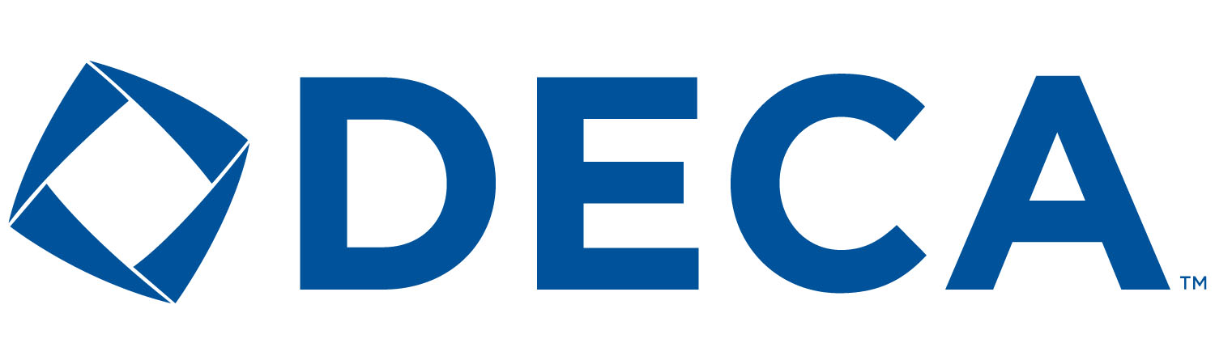  DECA – Association of  Marketing Students | FGE- Future Georgia Educators
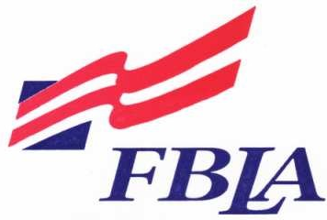  FBLA - Future Business  Leaders of America | Skills USA  Aesthetics, Audio/Visual, Construction, Cosmetology, Graphics  Healthcare, HVAC, Metals, Transportation
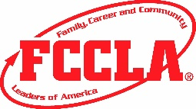  FCCLA - Family, Career, Community  Leaders of America | TSA – Technology Student Organization

Instructors
Cherokee Bluff High School - Karen Filchak Johnson High School – Cree Aiken
Chestatee High School - Holli Howard Lanier College and Career Academy – Kim Guy
East Hall High School – Staci Crain North Hall High School – Deana Harper
Flowery Branch High School - Christy Carter West Hall High School—Suzanne Haynes
Flowery Branch High School- Karen Filchak

Student Information

First Name: Last Name:
Address: City: Zip Code:
Email Address:
Cell Phone: Birth date:
Emergency Contact Name: Phone Number:
Who do you primarily live with?

Mother First Name: Last Name:
Address: City: Zip Code:
Email Address:
Cell Phone:

Father First Name: Last Name:
Address: City: Zip Code:
Email Address:
Cell Phone:

Guardian First Name: Last Name:
Address: City: Zip Code:
Email Address:
Cell Phone:

Program of Study

Please CIRCLE your intended path of study for each academic core area below:

English/Language Arts | Math | Science | Social Studies | Career Pathway  Circle one:
Standard Studies  Honors Studies | Standard Studies  Honors Studies | Standard Studies  Honors Studies | Standard Studies  Honors Studies | Completed  Pursuing  Pathway:

What is your career goal?

What post-secondary plans do you have following high school?

List three post-secondary educational institutions you are considering:
1. 2. 3.

Where do you see yourself in 5 years, related to your education and/or career goals?

Where do you see yourself in 10 years related to your education and/or career goals?

CNET Information
Student Name:

Graduation Year (circle one): 2019 2020 2021

Please print the following information neatly:

Business/Organization:
Business/Organization Address:
Business/Organization Phone #:
Business/Organization Email Address:
Supervisor Name:
Mentor Name:

Student Job Title:
First Date of Employment:
Hourly Wage: $
Typical Work Days (ex. Mon-Fri):
Typical Work Hours (Ex. 4pm-8pm):
Average Hours Per Week:
Off Campus Release Agreement

I understand as a member of the Work-Based Learning Program, _____________________________ (print student name) will be off campus during a portion of the school day. This does not always mean my student is going to work or to his/her placement during the release time. The work/placement schedule could vary as per the employer/mentor. If my student is working during a time that is different from their scheduled school release time frame, my student should use the school release time for school related work and assignments from home.

I understand my student is not allowed to stay on campus during his/her release period(s). I give my permission for my student to go home if his or her work/placement schedule is different from their scheduled school release period(s). I take full responsibility for my student’s safety while traveling. Hall County Schools and the WBL Coordinator are released from any liability incurred while my student is off campus, on the worksite, and traveling to and from the worksite. I assume responsibility for complying with all state laws (ie: licensing and automobile insurance) for my minor child.

I understand my student will receive a unit of credit per release period for this program. It is my student’s responsibility to attend all classes as scheduled. Class attendance is mandatory in order for my student to go to work/internship each school day.

I understand that my student will be off campus for the purpose of working at a paying job or an unpaid internship. In accepting this privilege, my student and I agree to the stipulations detailed below. The privilege of this off-campus experience may be revoked if any of these stipulations are violated or if the school feels it is in the best educational interest of my student.

- As parent/guardian, I will ensure my student has a school parking permit and a reliable vehicle for daily use.
- As a WBL student, I will sign in upon arrival to campus OR sign out before leaving campus daily.

Parent/Guardian Signature: Date:
Student Signature: Date:
We look forward to a successful year working with your son/daughter. If you have any questions concerning the program, please don’t hesitate to contact the Work-Based Learning Coordinator.

Employer Letter
Dear Employer or Mentor:

On behalf of the Work-Based Learning (WBL) Programs in Hall County, we would like to thank you for your willingness to mentor and evaluate our students.

At the beginning of school, there are a number of forms that the Georgia Department of Education requires us to have on file for each student. The required documentation is included in this packet. Please read and sign the Safety Training Agreement (pg 6). The Training Agreement (pg 8) details expectations for the student, the parent/guardian, the WBL Coordinator and the employer/mentor. The Initial Training Plan (pg 9) provides an area for you to list some specific job duties that the student is now performing or learning on the job. Please sign all designated areas on these three forms.

Several times throughout the school year, you will be asked to complete an evaluation form on the student employee/intern. This should require no more than a few minutes, but please know that your honest feedback is greatly appreciated.

We hope you will find our Hall County WBL students do an excellent job for you. Please don’t hesitate to contact one of us if you have any questions or concerns.
Sincerely,
Hall County Schools Work-Based Learning Coordinators

Safety Training Agreement
(student name), a student in the Work-Based Learning program at
High School and an employee/intern at has completed the necessary safety training for the current assigned position. The employer/mentor certifies that the proper procedures related to the job requirements have been shown to the student and that in the case of an emergency, the student has been given instructions on what to do to resolve the situation. The student understands that failure to comply with these safety procedures may result in personal injury or injury to others. The student agrees to follow all the safety rules and regulations of the current employer or internship placement.

Employer/Mentor Signature: Date:
Student Signature: Date:
WBL Coordinator Signature: Date:
Training Agreement

Student Name Student Job Title
The Work-Based Learning program prepares students for employment. To participate in the program, all parties must agree to the following:

The student agrees:
- To assist the WBL coordinator in finding an appropriate employment/internship position related to the career objective of the student.
- To obtain a school parking permit and to maintain a reliable vehicle.
- To attend class as scheduled in order to go to work/internship each school day.
- To discuss concerns of employment with the WBL coordinator and the work-site/internship supervisor – not with students, coworkers, etc.
- To positively represent the school and employer/mentor by demonstrating honesty, punctuality, courtesy, and a willingness to learn.
- If dismissed from employment/internship due to negligence or misconduct, he/she will risk receiving a failing grade for WBL and being removed from the WBL program.
- To communicate with WBL coordinator prior to terminating a job or internship experience.
- To cooperate if it becomes necessary for the WBL coordinator to change the student’s employment/internship placement.
- To be evaluated by the WBL coordinator and employer/mentor a minimum of once per grading period.
- To submit official check stubs as they are received and/or hours documentation forms on a monthly basis to the WBL coordinator.
- To notify the WBL coordinator and employer/mentor of any absences from work/internship for any reason well in advance. If an emergency arises, notify all parties as soon as possible.

The parents/guardians of the student agree:
- To encourage the student to effectively carry out his/her duties and responsibilities at both the school and place of employment/internship.
- To assume responsibility for their student’s safety and conduct from the time he/she leaves school/home until he/she reports to the job/internship; likewise, from the time leaving the job/internship until arriving home/school.
- To make inquiries concerning the student’s training, wages, or working conditions through the WBL coordinator rather than directly to the employer.
- To understand students must attend class as scheduled in order to go to work/internship each school day.
- To periodically view their student’s real-time grades and attendance through Infinite Campus.
- To schedule their student’s personal appointments (physical therapy, orthodontist, etc.) outside the WBL release timeframe.

The Work-Based Learning Coordinator agrees:
- To assist in the academic and occupational instruction of the student.
- To conduct supervisory visits to the student’s place of employment.
- To render assistance with educational and training problems of the student.
- To maintain required student records/documents.

Training Agreement - continued

The employer, mentor, and/or work-site supervisor agrees:
- To provide the student with a variety of work experiences to enhance employability skills and future career success.
- To schedule the student for at least 5 hours per week per release period during the school year.
- To adhere to policies and practices which prohibit discrimination on the basis of race, color, national origin, sex, and handicap in recruitment, hiring, placement, assignment to work tasks, hours of employment, level of responsibility, and pay.
- To provide occupational guidance and available instructional materials to the student.
- To designate an employee to serve as mentor/supervisor to the student.
- To complete student evaluation forms as required.
- To adhere to all federal and state regulations including child labor laws, minimum wage regulations, income tax, and Social Security withholding regulations (if the student is a paid employee).
- To consult with the WBL coordinator if student concerns/issues arise.
- To notify the WBL coordinator if disciplinary action is necessary.
- To notify the WBL coordinator if the student is absent without notice and/or is frequently absent.
- To sign Hours Documentation form to verify hours worked for unpaid interns.

All parties agree:
- This agreement extends through the end of the academic school year and will not be terminated without the knowledge of all parties concerned.
- The student will work an average of five hours per week per release period. To receive course credit, hours must be documented through official paystubs or official Hours Documentation form.
- When school is not in session due to inclement weather or school holidays, unpaid students are not required to attend their internship. It is up to parents to decide if student employees (paid employees) should report to work if scheduled.
- I have read this training agreement and will carry out the responsibilities delegated.

Employer/Mentor Signature: Date:
Student Signature: Date:
Parent/Guardian Signature: Date:
WBL Coordinator Signature: Date:
Initial Training Plan

Student Name Student Job Title
To provide the best learning experience for the student-worker, the employer/mentor agrees to provide a variety of work experiences that will contribute to the attainment of their career objective.

Employability and Soft Skills  - Follow all company safety guidelines and organizational policies.  - Arrive at the worksite/internship on time and prepared to work.  - Dress appropriately for the type of work to be performed and/or in accordance with a stated company dress code.  - Demonstrate ability to work well with others by displaying cooperation, courtesy and respect.  - Demonstrate strong communication skills in speaking, listening, and writing.  - Display honesty and integrity.  - Show initiative in taking on assigned projects, ask questions as necessary, and accept feedback and constructive criticism. | Employers/Mentors, please list specific job duties that will be performed on the job/internship (5 at minimum):
Employer/Mentor Signature: Date:
Student Signature: Date:
Parent/Guardian Signature: Date:
WBL Coordinator Signature: Date:

