Understanding Payroll
Activity 6 - February

Intern/Apprentice’s name: ______________________________

Directions:
Where appropriate, please write thoughts/answers in COMPLETE sentences. Math calculations must be shown (keyed or written) to receive credit. Remember, you are receiving a grade for this assignment.

6. Payroll Taxes- W-2, W-who?

So far, we’ve looked at earning an income, paying in taxes from your paycheck, and the required payroll forms. It’s important that totals are kept for how much money you’ve made and how much tax you have paid in for the year. Both federal and state governments require employers to send in a report stating how much each employee earned and how much taxes were paid in for each employee for the entire YEAR.

“I’m a student, why should I care about this??”
Because, as student, you may be entitled to get a refund of all or part of the federal and state tax you paid in!! Unfortunately, Social Security and Medicare are not refund eligible.

Calculate the following amounts & note your answers (not for a grade, just do the math!!):

- Wages $12,000 X 6.2% = _________ (Social Security is 12.4% but employees pay only half)
- Wages $12,000 X 1.45% = _________ (Medicare is 2.9% but employees pay only half)

Employees receive their yearly totals on a Form W-2 issued in January by the employer. Employers send Form W-2 s to both federal and state governments to report how much each employee made in wages and paid in taxes (this is how the government knows how much money we make in a year).

In January, employees receive a Form W-2 that shows the total income and taxes for the year before. Example of Form W-2:
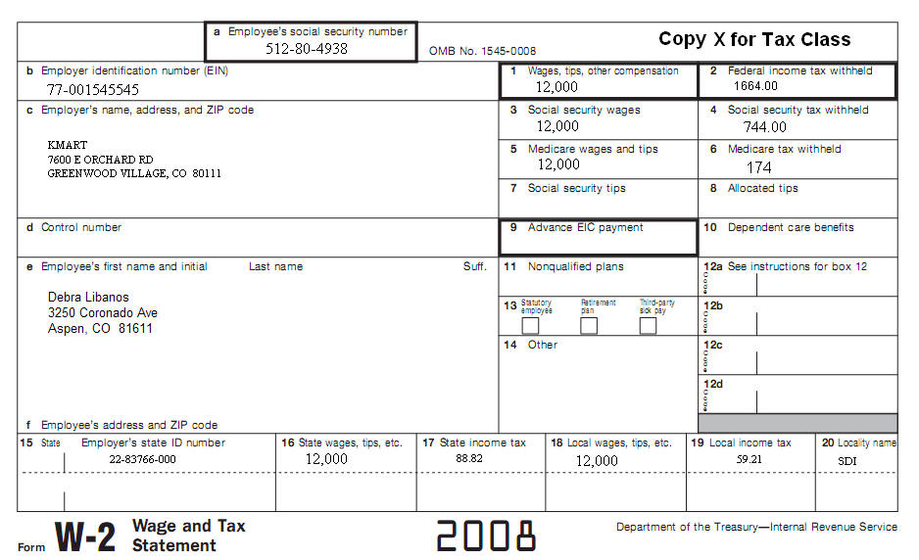

Box 1, 3, 5, 16 show the total wages earned from January – December. These amounts are usually the same but for some wages/taxes, they are not.
Box 2 shows the amount of federal income taxes withheld from your paycheck.
Box 4 shows the amount of Social Security withheld from your paycheck.
Box 6 shows the amount of Medicare withheld from your paycheck.
Box 17 shows the amount of state (Georgia) income taxes withheld from your paycheck.
**Boxes 18-20 are typically not used since usually zero local income taxes come from your paycheck.

Examine the W-2 and note the wage amount of $12,000 in boxes-1, 3, 5, & 16. Note the amounts for SS in box-4 and MC in box-6. Do they match your answers to the math problem on page 1? If they don’t match, work the math again!!
If you are an employee of more than one employer during the year, you should receive a Form W-2 from each employer.
Your employer(s) should have your W-2 to you by January 31st.

Go to page 3

Payroll Activity 6- February: Instructions:

Below, you will find seven payroll questions to answer about Form W-2. Use the W-2 example on page 2. Key your answers in the right column in the table below. You should bold your answers or change the font color. TAKE A PHOTO your answer-page and submit according to your school’s WBL Coordinator’s instructions.

1. | List the name of the employer:
2. | List the name of the employee:
3. | List the employee’s social security number:
4. | How much federal income tax did the employee pay in during the year while working at this business?
5. | How much state income tax did the employee pay in during the year while working at this business?
6. | What calendar year were the wages and taxes paid in that are listed on this  Form W-2?
7. | By what date should you have received your Form W-2 from your employer(s) for the prior year?

