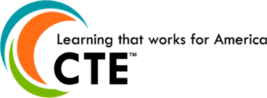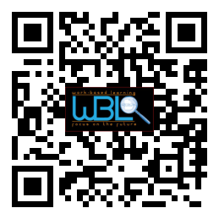0

**Advisory Committee Officers**

Mike Holman, Chair

Kirsten Fowler, Co-Chair

Holli Howard, Committee Coordination

Cree Aiken, Secretary

**Hall County WBL Coordinators**

Holli Howard, Chestatee High

Staci Crain, East Hall High

Christy Carter, Flowery Branch High

Felecia Doyle, Flowery Branch High

Cree Aiken, Johnson High

Karen Filchak, North Hall High

Deana Harper, North Hall High

Suzanne Haynes, North Hall High

Shenley Rountree, West Hall High

**Hall County CTAE Director**

Rhonda Samples

* **Welcome & Approval of Minutes**

Holli Howard, WBL Coordinator, Chestatee

* **WBL Success Stories**

Corey Roberts, Hall County Court House, Johnson

Torrie Odom, NEGMC Hospital Intern, West Hall

* **Youth Apprentice Conference Update**

Deana Harper, WBL Coordinator, North Hall

* **GeorgiaBEST**

Shenley Rountree, WBL Coordinator, West Hall

* **Board Involvement**

Mike Holman, WBL Advisory Committee Chair

* **Spring Meeting-Broaden Contacts**
  + May 4th 11:30AM-12:30PM
  + Invite and bring at least one guest from a different company/industry to hear about WBL
* **Questions/Closing Remarks**

## AGENDA

# WBL/YAP Advisory Committee

### January 27, 2015

### 11:30 a.m. - 12:30 p.m.

### Hall County Schools

*711 Green Street*

*Gainesville, GA 30501*